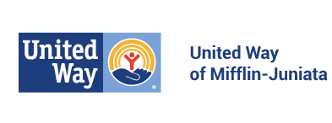

ANTI TERRORISM COMPLIANCE MEASURES

In compliance with the USA PATRIOT Act and other counterterrorism laws, the United Way of Mifflin-Juniata requires that each agency certify the following:

"I hereby certify on behalf of
(insert name of agency)
that all United Way funds and donations will be used in compliance with all applicable anti terrorist financing and asset control laws, statutes and executive orders."

Print Name:

Title:

Signature:

Date:

Return to:
United Way of Mifflin-Juniata 13 East Third Street Lewistown, PA 17044

